50x30 Team December Report
Steve and Pat Miller, Co-Leaders
The “50x30 Team” mission is to educate individuals, and advocate officials at local, state, and national levels to urgently work toward 50% GHG reduction by 2030, and NetZero by 2050. Climate Reality Leaders and all others are welcome to join us. Meets 3rd Thursday of the month at 7 PM.
An update on our September 30 letter to Gov. Murphy with our recommendations on steps for NJ to take to reduce GHG emissions in the state by 50% by 2030: On Nov 10, 2021, Gov Murphy signed Executive Order 274 setting a goal for carbon emissions reduction of 50% by 2030. We are still looking for a plan to make this happen based on our recommendations.
At our November 18 meeting we joined a Sierra Club webinar "Overview of Fixed Bottom Offshore Wind," produced by Wind Exchange US Dept of Energy. Some of the topics covered were: Why pursue offshore wind energy? How does a turbine work and what is the energy process? Operations, Maintenance and Turbine Spacing.
We also invited members to view (at their convenience) a film “The Condor and the Eagle,” about the spoiling of 4 different Indigenous peoples’ land in North and South America by oil and gas producers and the resultant ravaging of people’s health and the environment. Steve and Pat then led a discussion of the film on Nov 21.
Our December meeting will be Thursday, December 16 at 7 PM. A panel of experts will address Building Electrification. The event is being arranged by Steve and Pat Miller on behalf of the 50x30 Team and publicized by Sierra Club to its list of 80,000. Click on this picture to RSVP:
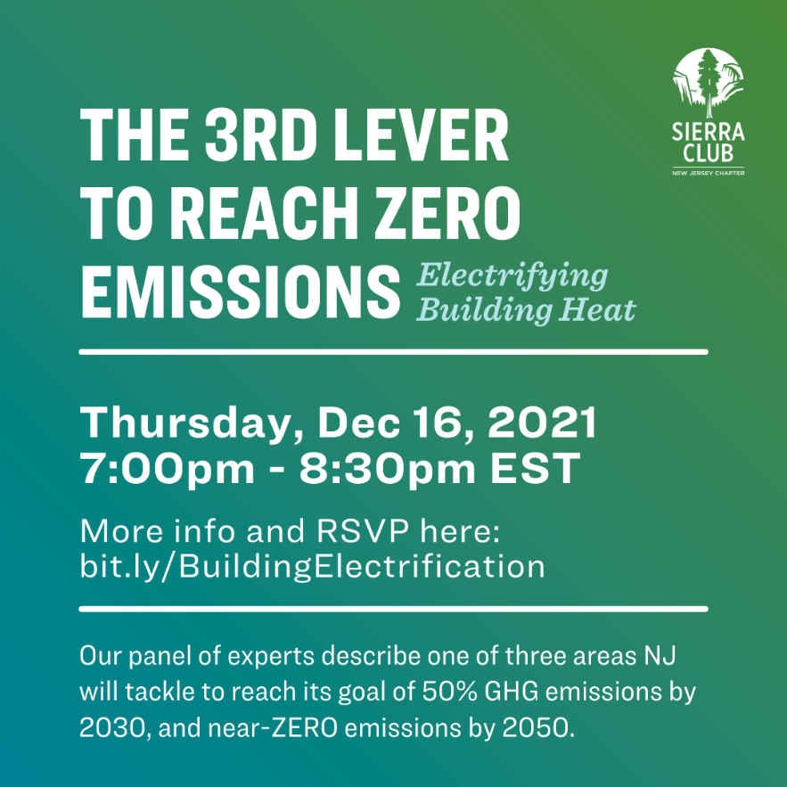
Hosts: Steve and Pat Miller, Climate Reality Leaders.
Speakers include Michael Winka (Executive Director, Sustainable Lawrence), Tom Schuster (Clean Energy Program Director, Sierra Club Pennsylvania Chapter), and David Hoh (HVAC, Home Comfort and Energy Expert).
We will also hear from the following homeowners about their experiences transitioning to clean electricity. These include Nancy Blackwood (homeowner and environmentalist), Greg Gorman (Conservation Chair, Sierra Club New Jersey Chapter Chapter), and Tom Schuster (Clean Energy Program Director, Sierra Club PA Chapter).
Learn More and Register Now!

